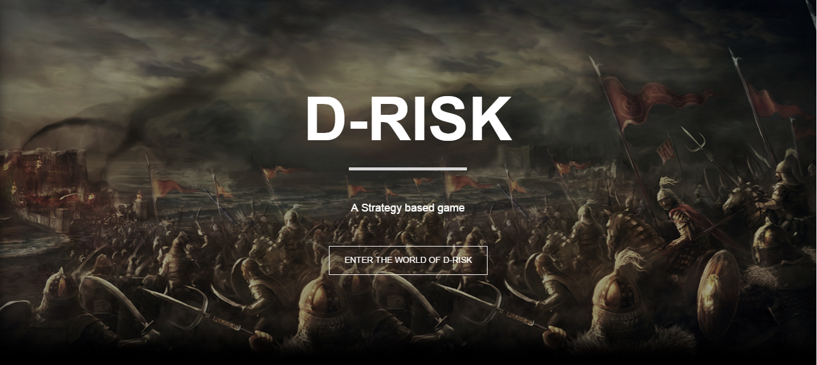

Web Application User Guide

|  |  |  |
| --- | --- | --- |
| **Version** | **Author** | **Date** |
| 1.0 | Arpit Mathur | 01/11/2015 |
| 1.1 | Arpit Mathur | 13/11/2015 |
|  |  |  |

DRisk-Team Inferno

**Table of Contents**

Introduction……………………………………………………….. pg. 1

Login……………………………………………….……………... pg. 2

New User Sign Up…..…………………………….……………… pg. 3

Game Options……………………………………...……………… pg. 4

Game Webpage…….……………………………..……………… pg. 5-6

**Introduction**

DRisk is a highly configurable computer based version of the Risk game. Risk is a board, turn-based game, played on a board depicting a political map of the Earth, divided into a number of territories, grouped into continents. The aim of the game is to achieve a goal, that is assigned to each player at the beginning of the game, and is kept secret from other players. Players control armies, which are deployed in occupied territories (and grouped in continents), and can be used to capture territories from other players. The results of attacks between territories are determined by rolling dice. In DRisk, the users play the game through a website.

This document guides a user through the necessary steps to start and play DRisk online game.

If you have any questions not covered in this user guide, please contact DRisk Team-Inferno.

**Login**

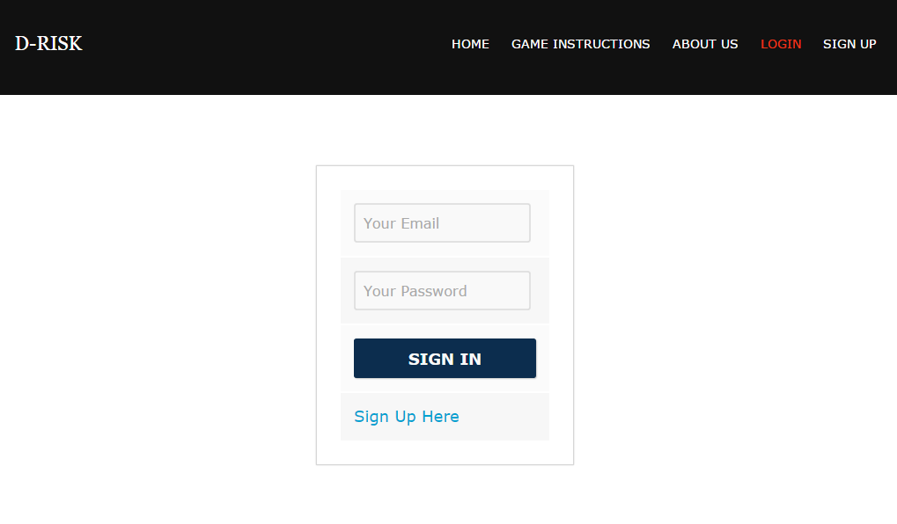

Users who have previously registered for the DRisk Web Application must login by: Entering their **Email Id**.

Entering their **Password**.

Selecting **SIGN IN** to advance to the next screen and begin using the application.

**Site Registration**

Users who have not previously registered for the DRisk Web Application must select “**Sign Up Here**” to access the “**New User SignUp**” page.

**New User Sign Up**

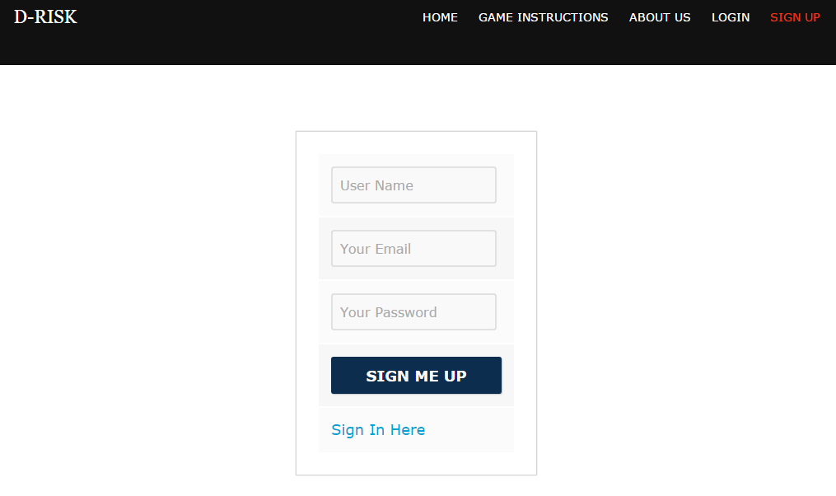

Users will be asked to enter or select the following information (all items in blue are required):

**Name**

Enter the user’s name.

**E-Mail**

Enter the user’s e-mail address. E-mail addresses are not case sensitive.

**Password**

Passwords must be at least eight characters long and contain at least one letter character and one numeric character. Passwords are case sensitive.

**Sign Me Up**

Select "Register" to submit the registration information and continue to the next screen.

**Game Options**

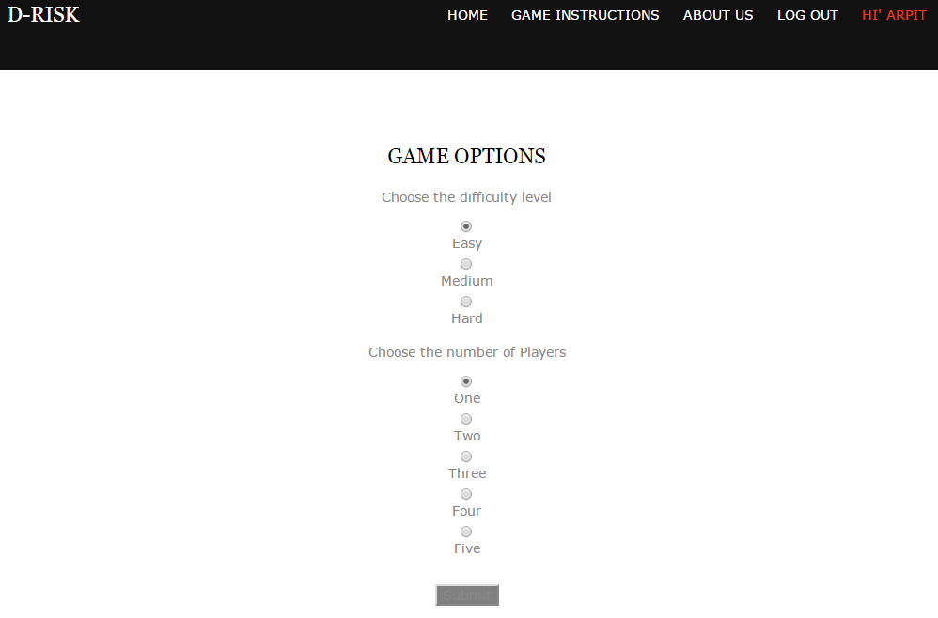

**Choosing the difficulty Level**

Select any one of the level of difficulty from the options “Easy”, “Medium” and “Hard”.

**Choosing the number of players**

Select the number of players with whom you want to play the game.

**Submit**

Click on the submit button to confirm your selections.

**Game Page**

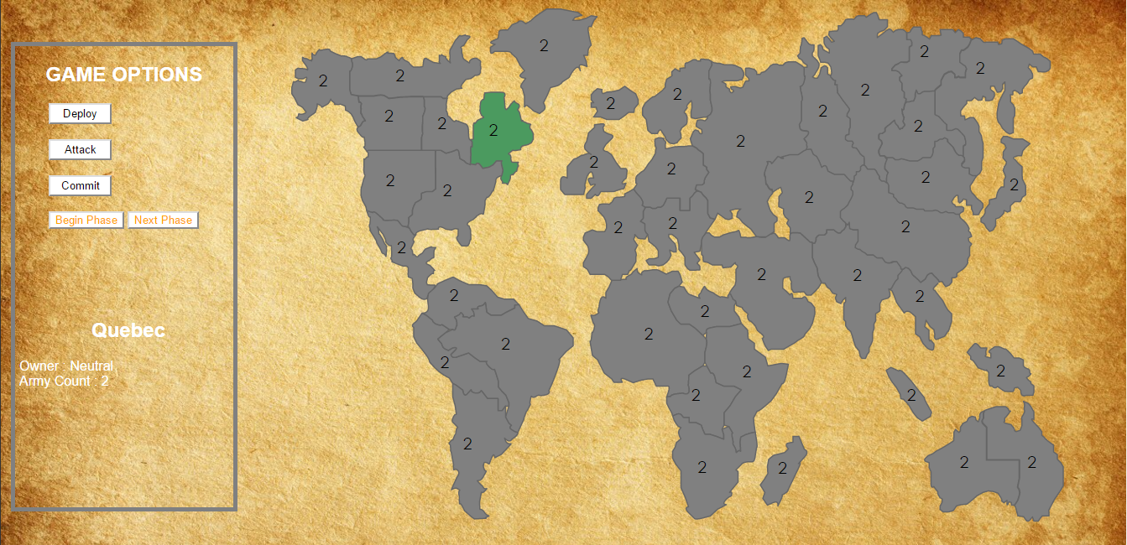

**Map**

The map is the center of attention in a game. The map is simply a collection of territories, where each territory is filled with a color that indicates the player that controls the territory, and a number that indicates how many armies are present on that territory. There are some territories that are neutral and are represented by gray color. The numbers of armies that are present in the neutral territories are two in the beginning and will change as the game proceeds and are occupied by a specific player.  
All territories controlled by a specific players must keep at least one army on them at all times.

# CONTROLS

A player can hover over a specific territory to see which player occupies that territory and how many armies are present in that territory. The name of the territory, the owner and the number of armies will be displayed in the left sidebar at the bottom. DRisk mainly utilizes the left mouse button to do all the actions to control the various phases of the game.

**PHASES**Each turn goes through three phases: Deploying Armies, Attack/Transfer, and Execute. These buttons can be seen on the left side of the main map once you start the game.  
 **Deploy** is mainly to deploy your armies in the territories. Each turn, you receive new armies that you can add to territories you control. When a player is in a deploying phase he will be given a total of five armies which he can deploy in the territories controlled by him. Once the player reaches the limit of 5 armies he has to move to the next phase by clicking the next phase and then the attack phase to start attacking the neighboring territories. The deploying of the army can be done by the left click of the mouse on the territories the player wants to deploy. Once an army is deployed in the territory the count of the army will increase in that territory by one, which can be seen on the territory as well as on the sidebar by hovering over the territory.

**Attack/Transfer Phase** allows you to attack other territories or transfer your armies between territories you control.

Each army can only do one attack or transfer, which means each army, can only move to directly adjacent territories in a given turn. If it moves to a territory owned by you, that's considered a transfer. If it moves to an enemy territory (either another player or neutral), that's considered an attack.

Once you are in attack phase, when you click on a territory owned by you it will show you the available territories where you can move your armies. It could be your own territory or could be an enemy/neutral territory. After that the user have to click on those neighboring countries which ask you to enter the number of armies to be transferred.

Transfers are simple, and always succeed. The army simply moves from one territory to the adjacent territory.

Attacks are little complicated. As a rule of thumb a user should attack with army that is atleast twice as many as defending army.

**Execute Phase**

Once the player clicks on this button the chance passes to the next player. Once the chance is passed to the next player, the first player will not be able to execute any other chances until the next player is done with his turn.

This same will follow for if there are more than two players.